### ANCAS

The first algorithm, ANCAS **[****2****]** uses cubic polynomial as an approximation of a function over an interval. Given 4 points in time and the respective location and velocity vectors for 2 objects, we can find the TCA by:

Algorithm 1: ANCAS on 4 points, (the original algorithms description can be found at **[****2****]**)

**Input**: 

**Output**: 





Map the time points  to  on the interval 

Calculate  using **Eq.(****5****/****2****)** with the points 

Fit cubic polynomial to  according to **[****2** **,Eq.1f-1j]** over 

Find the cubic polynomial real roots

Fit cubic polynomial for  in the interval 

**for** each root  **do:**

calculate the distance  at  using **Eq.(****6****)**

**if** **:**



**end**

**end**

The cubic polynomial coefficients calculations described in article **[****2****]**.

Finding the roots of a cubic polynomials can be done by solving the 3rd degree equation and we will find between 1 to 3 real solutions. There is a problem with the algorithm, the point in time must be relatively close because the algorithm can only find up to 3 extrema points, so working with a large interval means we can miss possible points and even miss the actual point of the TCA. Because the root finding can be done fast using the 3rd degree equation the algorithm run relatively fast but the result can be inaccurate.

### CATCH

The second algorithm, CATCH **[****1****]**, uses **Chebyshev Proxy Polynomial (CPP)[****1****]** to approximate the functions. The CPP can give more accurate result, depending on the degree of polynomial we want to use. We can choose high enough degree to get the size of error we want. The algorithm work on time interval from 0 to , each iteration searches the minimal distance in an interval with size . The degree of the CPP is part of the algorithm input and appear as N.

Algorithm 2: CATCH the original algorithms description can be found at **[****1****, algorithm 2]**

**Input**: 

**Output**: 









While do:

Fit CPP  with order N to  according to **[****1** **, Eq.15]** over the interval 

Fit CPP with order N to  over the interval 

Find the roots of 

**for** each root  **do:**

calculate the distance  at  using Eq.(6)

**if** **:**



**end**

**end**



**end**

The algorithm needs N+1 points in time in each Gamma interval in order to create CPP of order N. After calculating the CPP coefficients we can use them to create a special NxN matrix called the companion Matrix **[****1****,Eq.18]** and the eigen values of this matrix are the polynomial roots. Using the roots, we found and creating CPP for  we can calculate the minimal distance in each interval and eventually the TCA and respective distance in . The problem with CATCH is the cost of finding the roots, which is the cost of finding eigen values for an NxN matrix, to deal with it, Dr. Elad describe in his article**[****1****,part 4]**  that we can get sufficient results for both runtime and error size, using degree of 16 for the polynomial. Using a constant degree give us deterministic run times and the size of the error is small enough for the required result.

### SBO-ANCAS

The third algorithm, SBO-ANCAS **[****2****]** is based on the ANCAS algorithm, still using cubic polynomial as an approximation of a function over an interval. But uses additional points to get better results. Given an initial set of 4 points in time, the respective location and velocity vectors for 2 objects, tolerance in time and tolerance in distance we can find the TCA by:

Algorithm 3:SBO-ANCAS on 4 points, (the original algorithms description can be found at **[**  **]**)

**Input**: ,,

**Output**: 





**Do**

Map the time points to  on the interval 

Calculate  using **Eq.(****5****/****2****)** with the points 

Fit cubic polynomial to  according to **[****2** **,Eq.1f-1j]** over 

Find the cubic polynomial real roots

Fit cubic polynomial for  in the interval 

**for** each root  **do:**

calculate the distance at  using **Eq.(****6****)**

**if** **:**

**end**

**end**

Sample and at using a propagator

**While**  OR

The cubic polynomial coefficients calculations described in article **[****2****]**.

Finding the roots of a cubic polynomials can be done by solving the 3rd degree equation and we will find between 1 to 3 real solutions. In each iteration after finding the minimum point we use the propagator to sample the location and velocity vectors at , we use the new and more accurate values and create a polynomial to get a more accurate minimum and so on until we reach the desired tolerance. This algorithm can give the best results, we can get the same results as checking every point with a small time-steps if we use small enough tolerance but with high cost in run time. SBO-ANCAS have an additional loop in each iteration and sampling points with the propagator is an expensive operation.

## Algorithms Complexity

### ANCAS Time Complexity

In ANCAS **[****2****]**, for each set of 4 data points we need to create 4 cubic polynomials, one for the relative distance derivative and 3 for the relative distance X, Y, Z. each cubic polynomials required coefficients calculation which consist of 4 equations **[****2****,Eq 1f-1j]**, meaning the complexity of finding the polynomial coefficients is constant. To map the time points to the interval [0,1] we use a simple calculation for each point **[****2****]** 4 times, one for each point.

Finding the solution for a 3rd degree equations is quite simple, using a given formula with a constant run time we get between 1 to 3 real result.

For each of the roots we found, we calculate the distance using **Eq.(****6****),** and check if we found a smaller distance. In the worst case we check 3 times.

Meaning for each set of 4 data points the complexity is (where k is a constant number):



Calculating the complexity for finding the TCA over **n** data points means we check the first 4 points and for each iteration after that we use the last point from the previous iteration as the first points meaning we need 3 new points, so we need to do  iterations.

The complexity of running ANCAS on **n** data points is:



### CATCH Time Complexity

In CATCH**[****1****]** algorithm we iterate through the number of time points in our external loop, 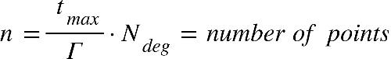

Where {"mathml":"<math style=\"font-family:stix;font-size:16px;\" xmlns=\"http://www.w3.org/1998/Math/MathML\"><mstyle mathsize=\"16px\"><msub><mi>t</mi><mrow><mi>m</mi><mi>a</mi><mi>x</mi></mrow></msub></mstyle></math>"} is the is end boundry in the time range where we're looking for mininal disdance, and equal to half of the smaller revolution time of the object **[****1****,part 4]**, The value of {"mathml":"<math style=\"font-family:stix;font-size:16px;\" xmlns=\"http://www.w3.org/1998/Math/MathML\"><mstyle mathsize=\"16px\"><msub><mi>N</mi><mrow><mi>d</mi><mi>e</mi><mi>g</mi></mrow></msub></mstyle></math>"} is the order of the polynomial, while we can change the chosen value of N, it was determined that {"mathml":"<math style=\"font-family:stix;font-size:16px;\" xmlns=\"http://www.w3.org/1998/Math/MathML\"><mstyle mathsize=\"16px\"><mi>N</mi><mo>=</mo><mn>16</mn></mstyle></math>"} give sufficient results.

Inside the loop we're doing the following steps:

1. Fit the CPP of order {"mathml":"<math style=\"font-family:stix;font-size:16px;\" xmlns=\"http://www.w3.org/1998/Math/MathML\"><mstyle mathsize=\"16px\"><msub><mi>N</mi><mrow><mi>d</mi><mi>e</mi><mi>g</mi></mrow></msub></mstyle></math>"} to {"mathml":"<math style=\"font-family:stix;font-size:16px;\" xmlns=\"http://www.w3.org/1998/Math/MathML\"><mstyle mathsize=\"16px\"><mover><mi>f</mi><mo>&#x2D9;</mo></mover><mfenced><mi>t</mi></mfenced><mo>,</mo><mo>&#xA0;</mo><msub><mi>p</mi><mi>x</mi></msub><mo>,</mo><mo>&#xA0;</mo><msub><mi>p</mi><mi>y</mi></msub><mo>,</mo><mo>&#xA0;</mo><msub><mi>p</mi><mi>z</mi></msub></mstyle></math>"} over each interval of points:

Assuming the arithmetic operations we use are basic operation done in time complexity of {"mathml":"<math style=\"font-family:stix;font-size:16px;\" xmlns=\"http://www.w3.org/1998/Math/MathML\"><mstyle mathsize=\"16px\"><mi>O</mi><mfenced><mn>1</mn></mfenced></mstyle></math>"}, we calculate the Chebyshev polynomials**[****1****]**. We'll iterate through {"mathml":"<math style=\"font-family:stix;font-size:16px;\" xmlns=\"http://www.w3.org/1998/Math/MathML\"><mstyle mathsize=\"16px\"><msub><mi>N</mi><mrow><mi>d</mi><mi>e</mi><mi>g</mi></mrow></msub><mo>+</mo><mn>1</mn></mstyle></math>"} points, which is a constant in our case, meaning that the time complexity will also be constant. Each iteration requires us to sample a new time point which will be our input parameter x, calculating the interpolation matrix with size of {"mathml":"<math style=\"font-family:stix;font-size:16px;\" xmlns=\"http://www.w3.org/1998/Math/MathML\"><mstyle mathsize=\"16px\"><mfenced><mrow><msub><mi>N</mi><mrow><mi>d</mi><mi>e</mi><mi>g</mi></mrow></msub><mo>+</mo><mn>1</mn></mrow></mfenced><mfenced><mrow><msub><mi>N</mi><mrow><mi>d</mi><mi>e</mi><mi>g</mi></mrow></msub><mo>+</mo><mn>1</mn></mrow></mfenced></mstyle></math>"}which is also constant.

The complexity of this step is: {"mathml":"<math style=\"font-family:stix;font-size:16px;\" xmlns=\"http://www.w3.org/1998/Math/MathML\"><mstyle mathsize=\"16px\"><mi>O</mi><mfenced><msub><mi>N</mi><mrow><mi>d</mi><mi>e</mi><mi>g</mi></mrow></msub></mfenced><mo>&#xB7;</mo><mfenced><mrow><mi>O</mi><mfenced><msub><mi>N</mi><mrow><mi>d</mi><mi>e</mi><mi>g</mi></mrow></msub></mfenced><mo>&#xB7;</mo><mfenced><mrow><mi>O</mi><mfenced><msub><mi>N</mi><mrow><mi>d</mi><mi>e</mi><mi>g</mi></mrow></msub></mfenced><mo>&#xB7;</mo><mi>O</mi><mfenced><msub><mi>N</mi><mrow><mi>d</mi><mi>e</mi><mi>g</mi></mrow></msub></mfenced></mrow></mfenced><mo>+</mo><mi>O</mi><mfenced><mn>1</mn></mfenced></mrow></mfenced><mo>&#xA0;</mo><mo>=</mo><mo>&#xA0;</mo><mi>O</mi><mfenced><mn>1</mn></mfenced></mstyle></math>"}

1. Finding the roots for {"mathml":"<math style=\"font-family:stix;font-size:16px;\" xmlns=\"http://www.w3.org/1998/Math/MathML\"><mstyle mathsize=\"16px\"><msub><mi>P</mi><mi>f</mi></msub></mstyle></math>"} will consist of calculating the companion matrix with a size of {"mathml":"<math style=\"font-family:stix;font-size:16px;\" xmlns=\"http://www.w3.org/1998/Math/MathML\"><mstyle mathsize=\"16px\"><msup><msub><mi>N</mi><mrow><mi>d</mi><mi>e</mi><mi>g</mi></mrow></msub><mn>2</mn></msup></mstyle></math>"} and finding the eigen values, using the complexity of matrix multiplication for this step, the complexity will be {"mathml":"<math style=\"font-family:stix;font-size:16px;\" xmlns=\"http://www.w3.org/1998/Math/MathML\"><mstyle mathsize=\"16px\"><mi>O</mi><mfenced><msup><msub><mi>N</mi><mrow><mi>d</mi><mi>e</mi><mi>g</mi></mrow></msub><mn>3</mn></msup></mfenced><mo>&#xA0;</mo><mo>=</mo><mo>&#xA0;</mo><mi>O</mi><mfenced><mn>1</mn></mfenced></mstyle></math>"}, rescaling each eigen value to the actual coefficient value also takes constant time.
2. For each time point we'll calculate in our interval we'll check if we found a new minimal distance, if we did, we'll update the minimum distance and the time of occurrence. This step also has a constant time complexity.

It means that the only inputs that determines our time complexity are the values of how long each interval time, and how long in the future we want to look it,

meaning the complexity equals the number of different time-points we measure, which is: {"mathml":"<math style=\"font-family:stix;font-size:16px;\" xmlns=\"http://www.w3.org/1998/Math/MathML\"><mstyle mathsize=\"16px\"><mi>O</mi><mfenced><mi>n</mi></mfenced></mstyle></math>"}

### SBO-ANCAS Time Complexity

In SBO-ANCAS **[** **]**, we are going over a set of n initial points, the outer loop check the first 4 points and for each iteration after that we use the last point from the previous iteration as the first points meaning we need 3 new points, so we need to do  outer iterations.

In the inner loop we run until we continue until we reach the desire tolerance in distance and time, thus the number of inner iteration depends on the size of tolerance in distance, the size of tolerance in time, the change in relative distance in time between the 2 objects and the distance between the initial time points.

Lets look at the tolerance in time condition for the inner loop, say we have 4 time points, , with distance between 2 time points of , and tolerance in time . To get the worst-case scenario we need to get each time a set of points with the biggest distances we can. Meaning we will get the point in the middle of the remaining distance between and its neighbors.

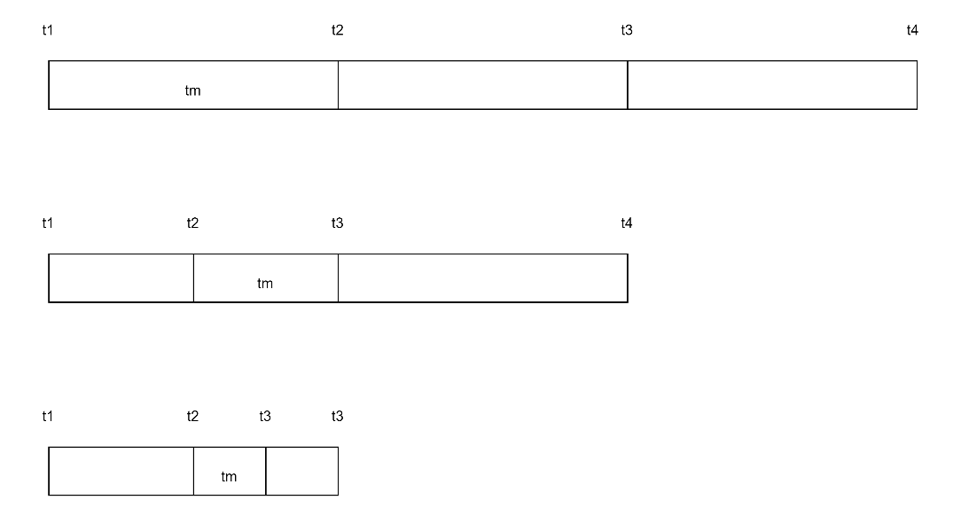

By looking at this we can see we will continue to run until we will get the remaining distance between to its neighbors to be smaller than , and each iteration the biggest distance is half of the distance in the iteration before the previous one meaning we will run until

In the inner iteration, similar to ANCAS, for each set of 4 data points we need to create 4 cubic polynomials, one for the relative distance derivative and 3 for the relative distance X, Y, Z. each cubic polynomials required coefficients calculation which consist of 4 equations **[****2****,Eq 1f-1j]**, meaning the complexity of finding the polynomial coefficients is constant. To map the time points to the interval [0,1] we use a simple calculation for each point **[****2****]** 4 times, one for each point.

Finding the solution for a 3rd degree equations is quite simple, using a given formula with a constant run time we get between 1 to 3 real result.

For each of the roots we found, we calculate the distance using **Eq.(****6****),** and check if we found a smaller distance. In the worst case we check 3 times.

After that we will use the propagator to get the values of and at , with complexity of

Meaning for each set of 4 data points the complexity is (where k is a constant number):

For **n** initial data points, and we get time complexity of

For some of the propagators the cost of getting a single point depend on the distance from the initial points and other variables, in our case SGP4 uses a set of calculation for every point we sample with no dependency on the distance from the initial point or any other point. Although the sampling of a single point is quite expensive its still with constant complexity.

By using SGP4 we have time complexity of:

### Space complexity

The space complexity of the algorithms is the same. SBO-ANCAS, ANCAS and CATCH uses a constant number of internal variables to help with the calculations. Because our task is finding a minimum, we only need one variable to store the current minimum without any dependency for the input size. We also use some internal variables representing the polynomial and other related logics. The only memory that is related to the size of the input is the input itself. The input consists of 2 location vectors, 2 velocity vectors and the time point value for each time point in our data set, so we can see that the size of memory the input uses is linear to the number of points we need to test. We get constant space complexity for the algorithms themselves and linear to the number of time point for the input: 